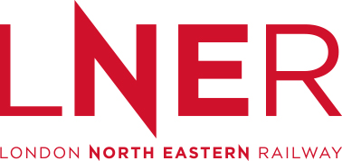

LNER Passenger Information During Disruption (PIDD) Delivery Plan

Updated June 2019

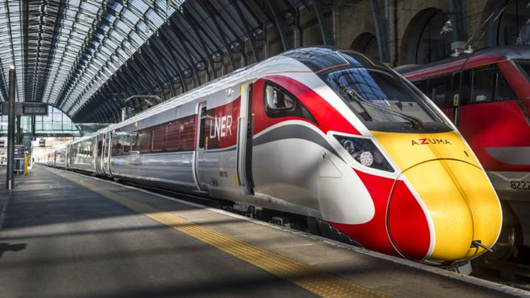

Our team at LNER work hard to give all of our customers the best possible journey experience, and to get you to where you need to be safely and on time. And we’re prepared for when it doesn’t go to plan; we have clear contingency plans in place to make sure we deal with the problem in the best way possible.
This document tells you what you can expect from us when things do go wrong. Along with our fellow train operating companies in the UK, we follow the industry Passenger Information During Disruption (“PIDD”) principles, which help make sure we are doing the right thing for our customers at all times.
We work closely with other train operating companies; Network Rail, Rail Delivery Group and Transport Focus to make sure our plans are consistent and up to date.

So what happens when disruption hits?
We don’t live in a perfect world and not all infrastructure and trains work perfectly all of the time, despite regular maintenance and improvements. Equally nature isn’t always on our side and people can do some unexpected things so it makes sense to be prepared.

We manage our response to disruption incidents from our Control Centre which is based in York, and we work closely with Network Rail and other train operators to minimise the impact for all customers.

When our teams become aware of an incident or issue, we use a colour coding system (green, yellow, red or black) to help us provide the most effect response:
Service Status | Description
Green | Normal Service:  - Services are running normally.  Or  - There is a single delay to one service of between 20-30 minutes.  Or  - There is a single cancellation.
Yellow | Minor Disruption:  - There is an incident, or a combination of incidents, causing 5 or more services to be delayed by over 30 minutes.  Or  - There are 4 or more consecutive service cancellations.  Or  - An incident is under investigation which could begin to affect the route.  Or  - The service is returning to normal but some trains may still be delayed or altered.
Red | Major Service Disruption:  - There is a partial route closure.  Or  - An incident is causing or likely to cause multiple delays of at least 60 minutes. Disruption is estimated to last for at least 2 hours.  Or  - There are 4 or more consecutive service cancellations.  Or  - Service diversions are being implemented.
Black | Major Route Disruption:  - There has been a route closure.  Or  - There is weather-related significant disruption.  Or  - There is a prolonged incident which will significantly affect the route for 12 to 24 hours, causing multiple cancellations and alterations to the service.
If the service status is escalated to yellow, red or black status we will take steps to ensure you are given a regular update regarding the cause of disruption, what is being done to resolve the situation, and our advice to help you complete your journey.
These actions might include:
- Activating our on-call process to get more staff to stations and trains (including volunteers from our office-based teams) to help customers where required.
- Increasing the frequency of information updates from our Service Delivery Team (‘Control Centre’) to at least every 20 minutes. This information includes the nature of the problem, the impact on customer journeys, and the customer advice.
- Displaying special messages on:
  - Customer Information Systems (CIS screens) and Electronic Information Screens at our stations
  - LNER website
  - LNER Wi-Fi portal (this contains journey updates and service status banners)
  - National Rail enquiries website
  - LNER Twitter feed
  - LNER Facebook account
  - Passenger Information Screens (these are on board some of our trains)

In the event of train delays, alterations or cancellations we may:
- Arrange ticket acceptance with other train companies so that you can complete your journey with an alternative train operator.
- Provide information on alternative routes available to enable you to complete your journey.
- Provide rail replacement in the form of coaches or taxis.
- In the rare event that it is not possible or practical to provide alternatives we’ll try and keep you comfortable and get things moving as quickly as we can.

This information will be communicated to you by our frontline teams as appropriate.

Support for customers requiring assistance
On Board our Trains
- We have written procedures for our station and onboard staff to follow in the event of an emergency which deal specifically with the arrangements for dealing with disabled customers.
- In the event of significant delay or service disruption we focus on the requirements of customers with disabilities or impaired mobility to ensure they are well supported. Our on board team has details of all customers who have arranged mobility assistance through Passenger Assist, therefore they can check on these customers regularly.
- We also encourage anyone requiring help or advice who hasn’t booked assistance in advance to make themselves known to the on board staff.
At our Control Centre
- The on board team are regularly in contact with our Service Delivery Team (Control centre) which is based in York. We have dedicated Customer Information Controllers who will be able to make arrangements for individual customers during disrupted journeys, for example, if a customer using a wheelchair requires an onward connection by taxi, we will ensure the taxi provided will accommodate a wheelchair.
- This team also monitor facilities on trains and if there any restrictions, e.g. if the universally accessible toilet is not available, we will do everything we can to let customers know before joining the train.
At our Stations
- Our station teams have a list of all booked customer assistance jobs for each day and will allocate resources accordingly in order to ensure each customer receives the assistance they require. If a train changes platform after a person requiring assistance has already been helped to the original platform, our staff will return to assist them to the new platform.
- Where services or facilities for disabled customers at our stations are altered or removed we’ll provide reasonable replacement services or facilities that are accessible.
- Where trains are replaced by other transport, we will give oral and visual information to enable customers to find the substitute transport, and we will provide staff assistance where required.
Our Assisted Travel Team (at our Customer Contact Centre)
- Our Assisted Travel team will receive information about any alterations to train services. When such changes are made, the team will review the Passenger Assist information and take appropriate action.
- If a service is significantly delayed or cancelled and customers have booked assistance in advance through Passenger Assist (and provided their contact details), then the team will contact them to advise of the change to their planned journey and to re-book the assistance if required.

Where can you go to find out more information?
LNER website
Our website is designed to make sure information about our services is easy to find and understand.
- Our homepage www.lner.co.uk shows a service status banner – this shows you what is happening on the network as soon as you enter the site.

- A green banner shows that there is a “good service” and trains are running as normal.
- A beige banner alerts you that there are “minor delays on some routes”.
- An amber banner alerts you that there are “major delays on some routes”. This will provide the location of the travel disruption, along with a link to further information about the impact of the disruption and our advice to customers. In the event that we invoke ‘Black Status’, and therefore advise customers not to travel, an amber banner will be used.

Our Travel Information page provides more detail about what is happening, including the affected routes, details, customer impact and advice, as well as information about how to claim delay repay.
www.lner.co.uk/travel-information

Our Travel Alerts page contains a full list of all live travel updates next to our Twitter feed. Here you can also find out information about any specific changes to our train services. For example, sometimes we need to take a coach out of one of our trains to complete repairs and so we’ll need to move customers’ seat reservations to different coach – if this is the case we’ll let you know, or we may need to make some changes to our catering arrangements, whatever it is, we’ll do our best to keep you informed. There is also an option to sign up to ‘Journey Alerts’ so that you can be kept updated with text message alerts about your chosen service(s).
www.lner.co.uk/travel-information/travel-alerts
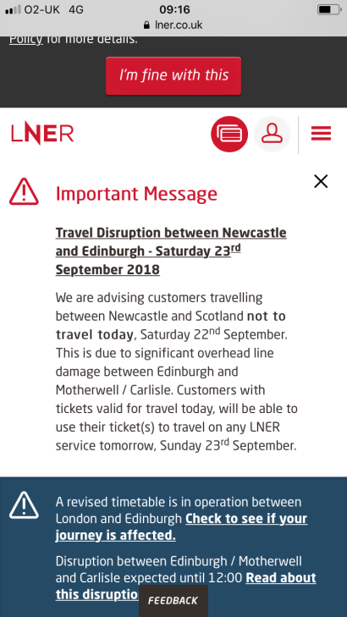

When there is serious disruption or we have advance warning of expected travel disruption, for example, if we receive a forecast of poor weather, we will put a special message up on our website, this is known as a ‘site-wide message’.

‘Journey Alerts’ service
We provide a text and email alerting service, this gives you the opportunity to register a regular journey and receive alerts and updates via email and SMS when there are any issues relating to this service. This tool is currently provided by National Rail Enquiries and you can sign up by visiting the Travel Alerts page of the website.
www.lner.co.uk/travel-information/travel-alerts

Our people
Our frontline teams will do their best to help you at all times. They have all been issued with iPhone so that they can access the latest information to help tell you what’s going on, and to give you advice about what to do.

Stations screens and announcements
Our stations are all fitted with customer information systems, these are screens which will provide information about any train delays or travel disruption. Our station teams will also make manual announcements to give you information about any disruption or delays, and to tell you about train running information and travel advice.

LNER Twitter feed and Facebook page
Our Social Media Team is on hand 24/7 to help answer your questions and queries. They are based in the Control Centre which means they have immediate access to the latest updates about what is going on in times of disruption and will be able to keep you informed at all times.
You can find our Twitter feed at https://twitter.com/LNER and you can also go to our Facebook page (https://www.facebook.com/LNERail/) where you will also have access to live updates.

Customer Services
You can call our Customer Services team on 03457 225 333, they are based at our Contact Centre in Gosforth, Newcastle and are available every day between 07:00-22:00 to help answer your queries.
They can also be contacted at:
Freepost RTUH-TUGH-GCLZ
Cramlington
NE23 1WG
Email:
customers@lner.co.uk

National Rail Enquiries (NRE)
The NRE website and call centre also provide useful information during disruption, this includes information about disruption affecting our services and those of other train operators. They get their information from updates provided by the LNER Control Centre Team. This ensures that information provided by both LNER and the NRE is consistent across all channels.

How do we measure how we’re doing?
We’re always looking at ways to improve the way we handle disruption, and most importantly, how we keep you informed about what is going on. We use a number of different measures to make sure we’re meeting your expectations.
This includes:
- The National Rail Passenger Survey (NRPS) results
This survey is conducted by Passenger Focus and tells us what you think about how well we deal with delays. This information is collected twice a year and includes feedback from more than 50,000 customers!
- Our Net Advocacy Score (NAS)
Any customer who has booked a ticket through the LNER website (and opted into our marketing communications) will be sent an email asking them for feedback following their journey. It’s a chance for customers to tell us what they think about the service they receive from us and how well we’re doing. It centres around one particular question which is:
‘Based on your most recent journey, how likely are you to recommend LNER to friends, family or colleagues?’
- Our provision of ‘Passenger Information During Disruption’ (‘PIDD’)
This involves measuring how quickly we provide information to our customers and frontline teams during disruption. We base this on the percentage of updates that have been provided within 20 minutes. We also look at how many services have been altered and cancelled, and check how many of these were updated on our customer information systems, website and mobile applications. Both of these measures help us to understand if we are giving you the information you need as quickly as possible during times of disruption.
Following any major disruption, we will undertake a post-disruption review – this is where we look at how well we handled a particular disruption event, from the decisions we made on the day - to the quality of information provided. We then produce an action plan based on any recommendations that have been made - this makes sure we do things better next time and always take learnings from past events.

So, what are we doing to make improvements?
At LNER we’re continually looking for ways to make improvements for our customers. In 2019 customers can look forward to...

New trains!
Our new Azuma trains launched in May 2019, some of the key benefits include:
- More trains and more seats – we’ll be increasing our fleet from 45 to 65 trains, this means we’ll have 6,000 more seats available every day!
- The trains are a diesel-electric hybrid. This “bi-mode” technology will make them more resilient during disruption.
- Azuma has technology, quality and reliability built in - so you can look forward to smoother, quieter, more reliable journeys.

Personalised customer alerts
In summer 2019 we’ll be introducing the first phase of our new automated, personalised customer alerting tool. This will enable LNER customers to receive instant notification of any service alterations, delays or last minute platform changes.

